RailPad: Smart Menstrual Hygiene Vending Machine for Railways
RailPad is an IoT-enabled smart vending machine designed to provide instant access to menstrual hygiene products inside railway coaches and stations. The solution aims to make rail travel safer, smarter, and more inclusive for women travelers.
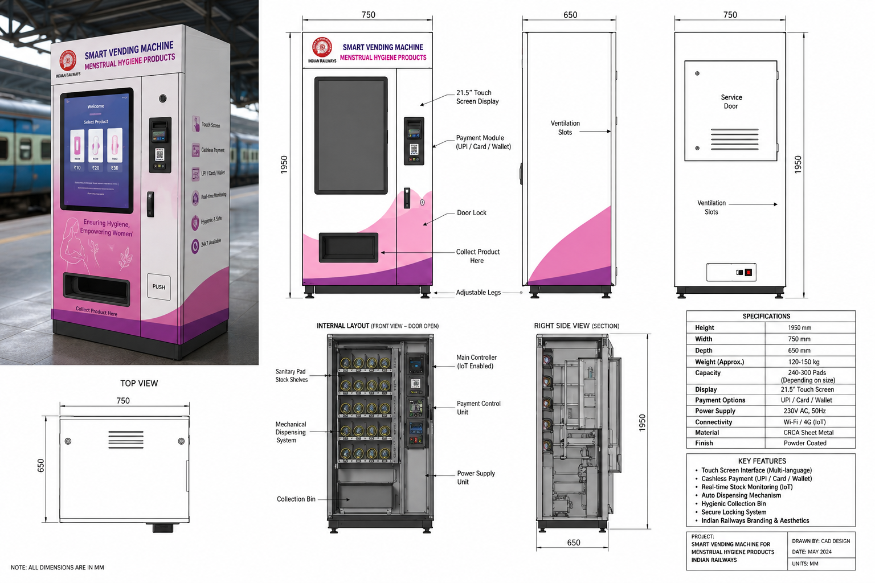

1. Problem Statement
Women frequently face challenges accessing sanitary products during long-distance rail travel. Unexpected menstrual emergencies can cause discomfort, stress, and health concerns, especially when trains are far from stations or retail facilities.
Challenges Faced by Women Travelers
- Over 1.8 billion women menstruate globally, yet access to hygiene products during travel remains limited.
- Unexpected periods during long railway journeys create stress and discomfort.
- Most trains lack immediate access to sanitary products.
- Remote routes and long-distance travel make product availability difficult.
- Lack of hygiene facilities impacts passenger comfort and safety.
- Railway authorities lack data on demand and consumption patterns.
Current Scenario
❌ No real-time product availability
❌ No smart monitoring system
❌ Limited accessibility during emergencies

2. Proposed Solution
RailPad is a compact, railway-grade smart vending machine installed inside train coaches. Passengers can purchase sanitary pads through UPI, NFC, cards, or digital wallets. The machine automatically dispenses products and updates inventory data in real time.
RailPad – Smart Menstrual Hygiene Vending Machine
A compact IoT-enabled vending machine installed inside railway coaches that provides:
✅ Sanitary Pads
✅ Panty Liners
✅ Emergency Hygiene Kits

3. Key Features
• Cashless payments (UPI/Card/NFC)
• IoT-based inventory monitoring
• Touchscreen interface
• Multi-language support
• Real-time cloud dashboard
• Secure locking system
• Easy maintenance and refill mechanism
4. Technical Architecture
The system consists of an ESP32 controller, payment module, cloud connectivity, inventory sensors, dispensing motors, and a centralized dashboard for railway operators.

5. Benefits for Railways
• Improved passenger experience
• Enhanced hygiene and safety
• Smart inventory management
• Additional revenue opportunities
• Data-driven decision making
Market Opportunity
India: A Massive Railway Passenger Ecosystem
India operates one of the world's largest railway networks through Indian Railways, carrying over 24 million passengers every day across more than 13,000 passenger trains and approximately 7,000 railway stations. A significant proportion of these passengers are women traveling for education, employment, healthcare, tourism, and family commitments.
Despite continuous advancements in railway infrastructure, access to menstrual hygiene products during train journeys remains limited. Women frequently face unexpected menstrual emergencies, particularly during long-distance travel where immediate access to pharmacies or convenience stores is unavailable. This gap presents a significant opportunity to introduce smart, accessible, and technology-enabled menstrual hygiene solutions directly within train coaches.
By deploying RailPad across premium, express, and long-distance trains, Indian Railways can improve passenger comfort, enhance inclusivity, and strengthen its commitment to women-friendly transportation infrastructure.
India Market Potential
🚆 24+ Million Daily Railway Passengers
🚉 7,000+ Railway Stations
🚄 13,000+ Passenger Trains
👩 Millions of Women Travelers Daily
📈 Large Untapped Market for Smart Hygiene Infrastructure

Global Opportunity: Scaling Across International Rail Networks
The challenge of accessing menstrual hygiene products during travel is not limited to India. Women across the world experience similar difficulties while traveling on long-distance trains, regional rail networks, and high-speed railway systems.
RailPad is designed as a globally scalable platform that can be adapted to different railway environments, payment systems, languages, and operational requirements. Its IoT-enabled architecture allows centralized monitoring, predictive inventory management, and seamless deployment across international transportation networks.
Potential deployment opportunities exist across major railway operators including:
Europe
• Deutsche Bahn (Germany)
• SNCF (France)
• Trenitalia (Italy)
• Renfe (Spain)
• Eurostar (United Kingdom–Europe)
Asia
• Japan Railways Group (Japan)
• China Railway
• Korail (South Korea)
• Taiwan High-Speed Rail
• Indian Railways
North America
• Amtrak (United States)
• VIA Rail (Canada)
Middle East & Emerging Markets
• Saudi Railways
• Etihad Rail (UAE)
• Turkish State Railways
• African Regional Railway Networks

Global Expansion Potential
RailPad is not merely a vending machine; it is a smart railway hygiene infrastructure platform.
The solution can be deployed across:
✔ Long-distance trains
✔ High-speed rail networks
✔ Metro and suburban rail systems
✔ Railway stations and waiting lounges
✔ Smart city mobility hubs
✔ Airports and bus terminals
With billions of passenger journeys occurring annually across global railway networks, RailPad has the potential to become the world's leading menstrual hygiene access platform for public transportation.
Vision
To create a future where no woman, anywhere in the world, faces a menstrual emergency without access to safe and affordable hygiene products during travel.
Estimated Reach
🌍 Potential Access to Hundreds of Millions of Women Travelers Annually
🚆 Deployment Opportunity Across Thousands of Trains Worldwide
📊 Scalable Smart Infrastructure Platform for Global Rail Networks

7. Future Scope
Future developments include AI-based demand forecasting, predictive refill alerts, integration with railway mobile applications, sustainability analytics, and deployment of eco-friendly menstrual products developed by Nariksha.

Conclusion
RailPad represents a practical and scalable innovation that addresses an overlooked need in public transportation. By ensuring access to menstrual hygiene products during travel, it contributes to safer, smarter, and more inclusive railway systems worldwide.

